FBLA Members Help

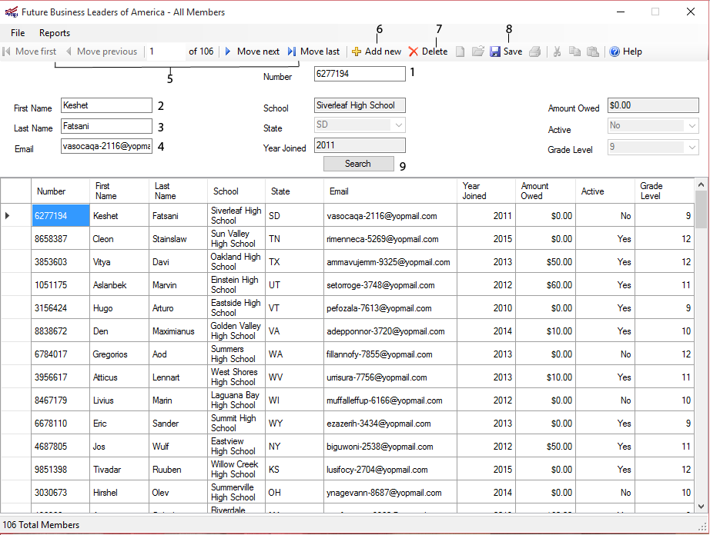

1. Displays the member number of the current member
   1. Searchable\*
2. Displays the first name of the current member
   1. Searchable\*
3. Displays the last name of the current member
   1. Searchable\*
4. Displays the email address of the current member
   1. Searchable\*
5. Buttons to navigate the database
6. Button to add a new member to the database
7. Button to delete the selected member from the database
8. Button to save the changes made and update the database

\*Searchable – Input a value and press the enter key or the search button to find the member based on that inputted value

General Operations:

* Adding a member to the database can be done by pressing the “Add new” button
  + All of the fields will become blank and the “Submit” button will appear
  + Default values are as followed
    - Year Joined: Current year
    - Amount Owed: $0.00
    - Active: Yes
    - Grade level: 9
  + Once all values are inputted, press the “Submit” button to validate values and add member to database
* All edits to a member’s information can be done by changing the value of a cell in the grid
* Deleting a member from the database can be done by selecting the row of the member and pressing the delete button